General Education Rubrics at SSC

South Suburban College is requesting that instructors associate an assignment in their D2L course with an SSC general education institutional rubric and then grade that assignment. This will allow SSC to gain valuable data to improve student learning.
Optional: D2L assignments can have multiple rubrics associated with it. This means instructors can associate a second rubric they create to a D2L assignment (the one for the D2L Gradebook), in addition to the SSC general education institutional rubric. Instructor can also view course specific rubric reports to gather information about their assignments.

Contents
Benefits of Using Rubrics 2
Create an Assignment and Attach an SSC General Education Institutional Rubric 3
Grading an Assignment that Uses a Rubric 4
What Happens With Rubric Data after an Assignment is Graded 5
Student View of Rubrics 6
What Students See Before a Submission 6
What Students See After a Submission 6
Rubric Reports 7
Assignment specific reports 7
Rubric specific reports 9
General Education Institutional Rubrics Reports 10
All Rubric Data 13
Using D2L Rubrics in Non-Traditional Ways 13
Creating an Assignment with submission type of Observe in Person 13
Attaching a Rubric to a Stand Alone Gradebook Column 14
Using Two Rubrics on One Assignment 17
Share a Rubric with a Colleague or Copy to Another Course 19

Benefits of Using Rubrics

Benefits to Students | Benefits to Instructors
- Provides a clear understanding of expectations.  - Students can self-evaluate work based on rubric before submitting.  - Assists students who are self-reliant and self-directed.  - Allows students to recognize their strengths and weaknesses and direct their efforts accordingly. | - Makes the grading process fast and easy, once the rubric is set up.  - Helps ensure Instructor neutrality and consistency when grading.  - Minimizes complaints about grading.  - Rubrics can be reused for various assignments.  - Statistic report helps instructors identify strengths and weaknesses across an entire class and adjust instruction appropriately.

Create an Assignment and Attach an SSC General Education Institutional Rubric
- Select Assignments in the course menu.
- Select New Assignment.
- Provide an Assignment Name.
- Complete all the fields for the assignment, such as score, due date, etc.
- Select Open Evaluation & Feedback.
- Select Add Rubric > Add Existing Rubric.
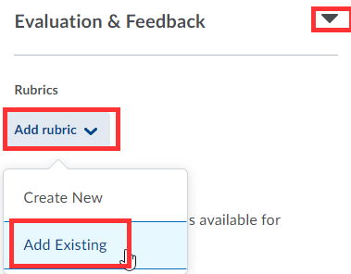
- Select SSC Written Communication Skills Rubric or SSC Technology Skills Rubric > and Add Selected.
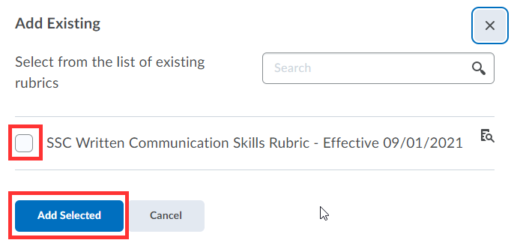

- Save Assignment.
- Rubric is now attached to this assignment.

Grading an Assignment that Uses a Rubric
- After students have submitted their assignments > select Assignments.
- Select Drop Down next to Assignment and View Submissions.
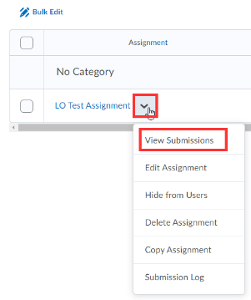
- Select a Student Submission.
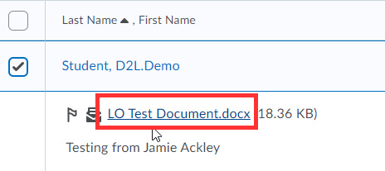
- Open Rubric.
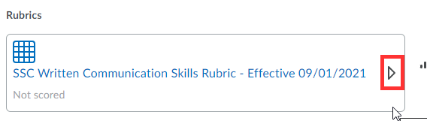
- Mouse over each criterion to apply rubric criteria to the student’s assignment.
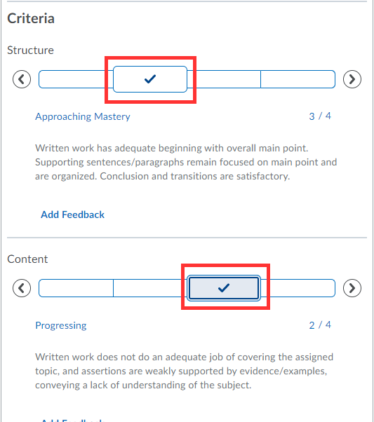
- Select Publish.

What Happens With Rubric Data after an Assignment is Graded
- The instructor graded the assignment.
- The student got notified that their assignment was just graded.
- Grade information was sent to the D2L Gradebook.
- Data from this rubric was sent to the course rubric area for the instructor to evaluate and view the rubric report.
- Data from this rubric was also sent to the D2L administrative reports for accreditation.

Student View of Rubrics

What Students See Before a Submission

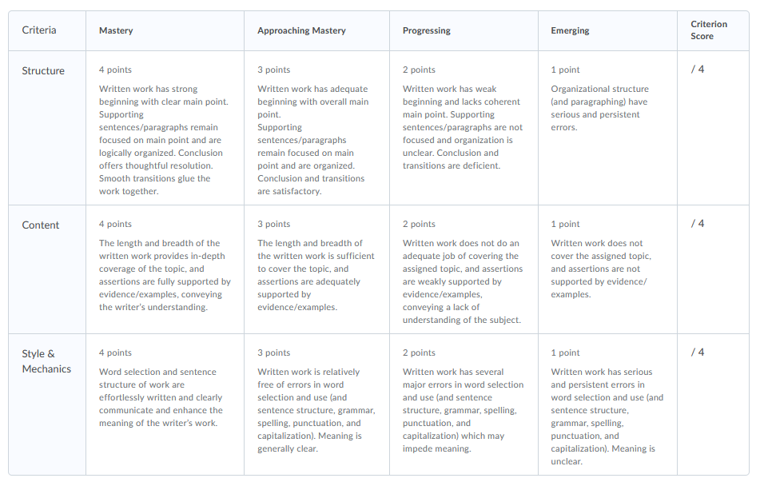 | 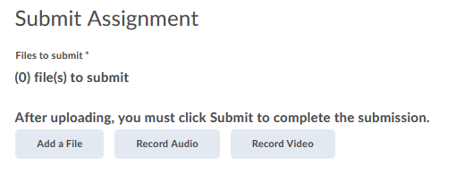

What Students See After a Submission
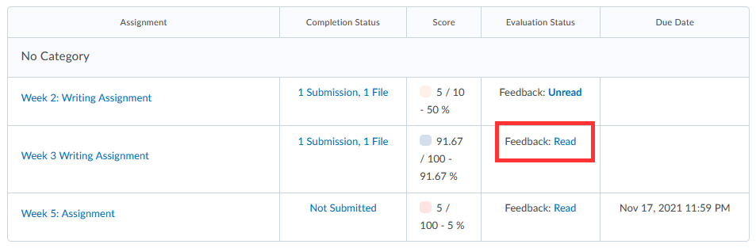 | 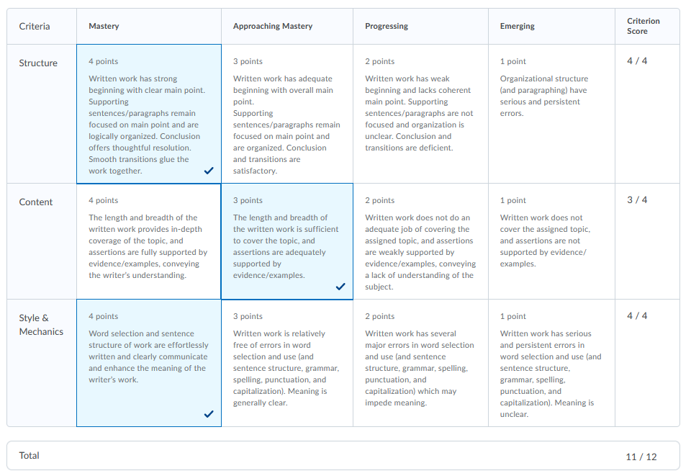

Rubric Reports
After grading an assignment, general education institutional rubrics data is sent directly to the D2L administration reports. Instructors do not need to do anything else.
However, if instructors would like to view statistic reports on rubrics in their course, there are several ways to view a rubric report.

Assignment specific reports
- Once you have completed your grading on an assignment, go back to the assignment and select View Submissions.

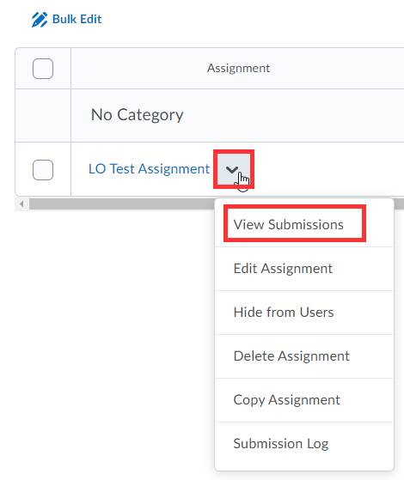
- Select Published.
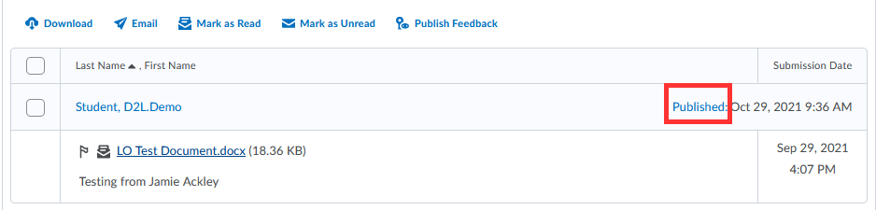

- Select the Chart Icon next to the rubric.
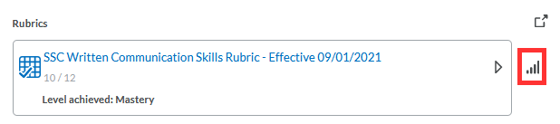
- Select Criteria Statistics or Individual Statistics.
- Criteria Statistics show the percentage of students that were graded on each criteria level. This allows an instructor to determine if they need to review content with students or whether students are on the right track.
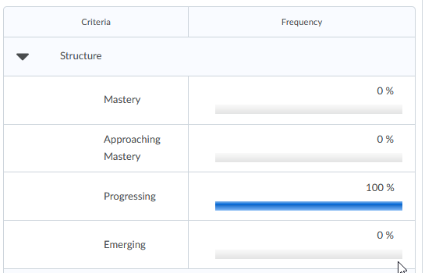
- Individual Statistics will show the overall scoring for each individual student.

Rubric specific reports
If you used the same rubric on a variety of writing assignments, for example, and you don’t want to go to each individual assignment to review the rubrics statistics report, go to the main rubrics tool.
- Go to Course Tools > Course Admin> Rubrics.
- All rubrics associated with the course will appear.
- Select View Statistics next to the rubric.
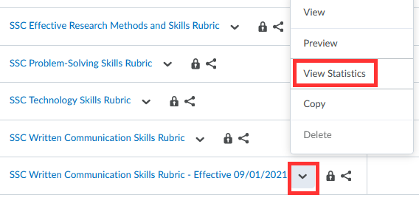
- Click on Competency Activities.
- This will show all the assignments that used the same rubric.
- Click on the Chart Icon next to each assignment to drill down on the data for that particular assignment.
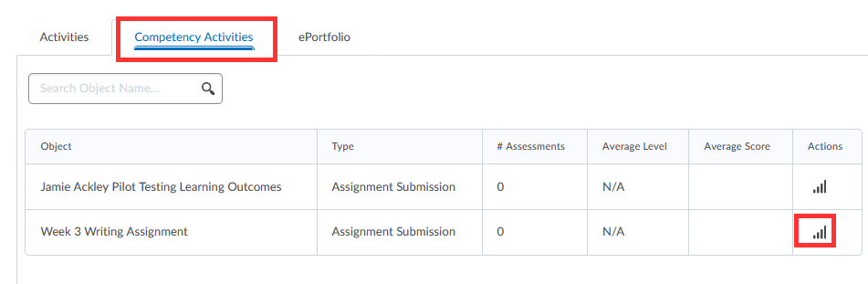

Download a Rubric Report within a Course:
- D2L does not include a download button when reviewing rubric results (D2L promises this is coming soon).
- A suggested workaround:
  - Open a new blank word document.
  - When looking at the D2L Rubric Reports, perform a screen capture (copy and paste doesn’t always work well in formatting – so screen capture works best).
  - How to perform a screen capture?
    - PC: select windows logo button, shift and the letter “S”.
    - Mac: shift, command button and number “3”.
  - Go back to the blank word document and select paste.
  - Save your word document when complete.

General Education Institutional Rubrics Reports
Since SSC is collecting data for General Education Institutional Rubrics, the college has recently rolled out and developed custom reports for instructors to view data collected for the entire institution. These custom dashboard reports can be found in the Insights Report Builder section of D2L. Here is how to access:
- After logging in to D2L and before entering a course – select:
  - Data Access > Insights Portal > Insights Report Builder.

- Select three lines in upper left-hand corner to access the Dashboard.
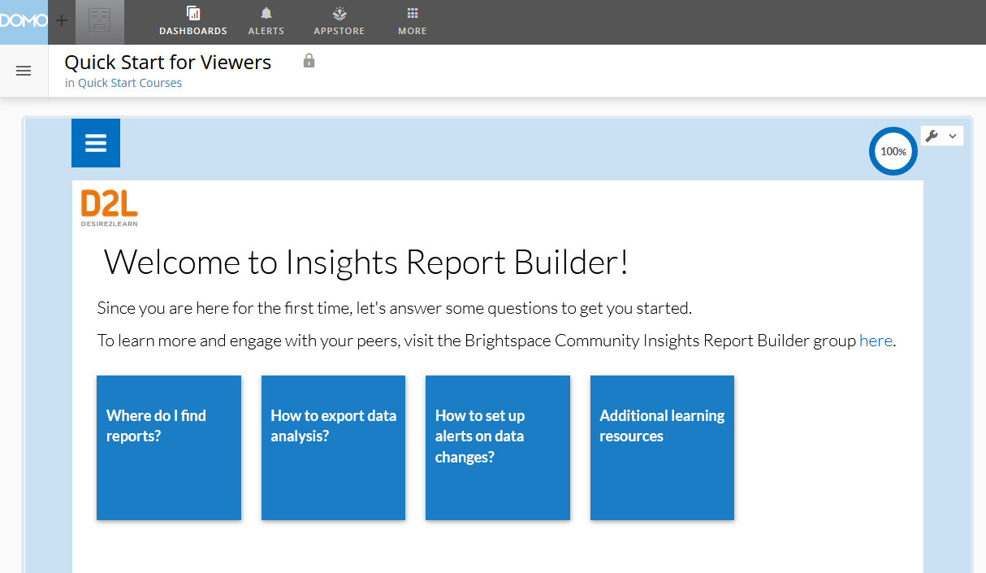
- Feel free to Pin this area, so it opens automatically next time you visit.
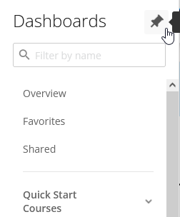
- Scroll to Institutional General Education Rubric Data Report.
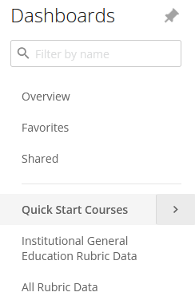
- This report is very robust with a variety of filters. Start by filtering by term.
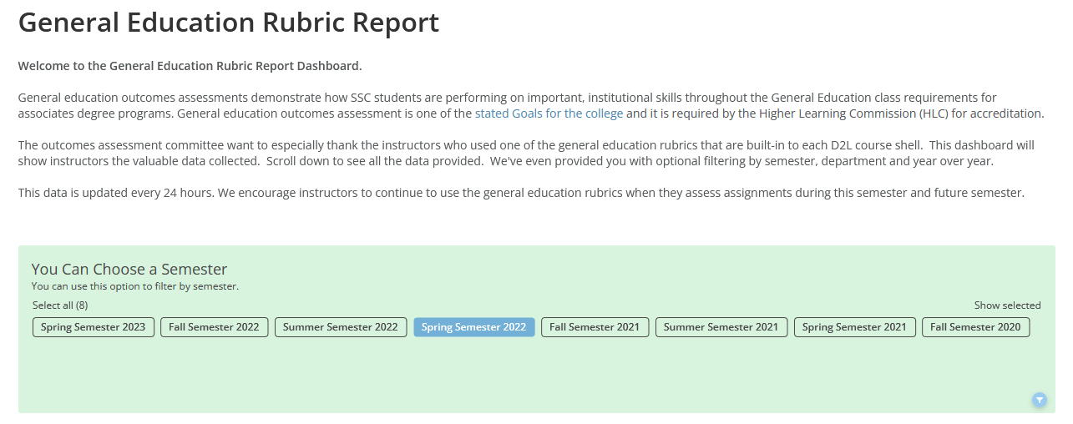
- Scroll down to see how many instructors used a General Education Institutional Rubric for that term.
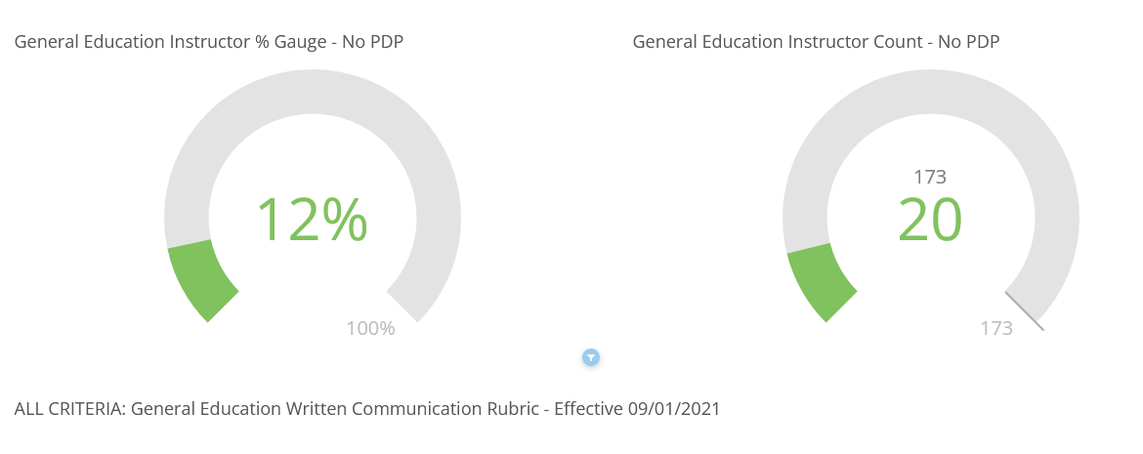
- Scroll down to see each General Education Rubric. Here is an example of the Technology Rubric and how students were accessed as a whole.
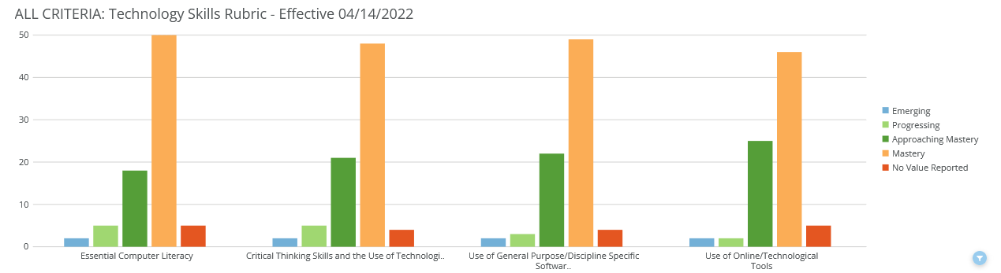
- To clear filters and start a new filter, just refresh your internet browser.

All Rubric Data
If you’d like to compare course rubric data over terms, use the All Rubric Data customized report within the Insights Report. Important – the All Rubric Data report – instructors can only see rubric data for courses they teach. They are not able to see other instructor’s rubric data.
- Select All Rubric Data.
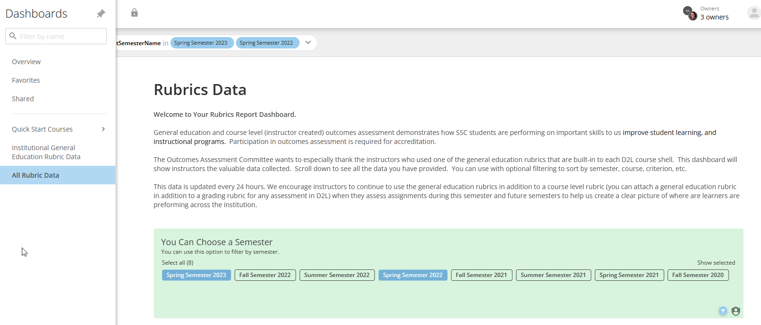
- Filter by terms (compare two terms), course, etc. and scroll down to see the custom report that was generated.
- To clear filters and start a new filter, just refresh your internet browser.

Using D2L Rubrics in Non-Traditional Ways
There are times when instructors would like to use a rubric in D2L which may not be considered a traditional written assignment and/or a grade may not be given. An example would be a musical performance or a voice lesson.
This can be done in two ways:

Creating an Assignment with submission type of Observe in Person
Instructors can create an assignment, as they normally do. But under Submission Type, switch to Observe in Person Assignments. Then attach a rubric. Grade the assignment like any other assignment in D2L.
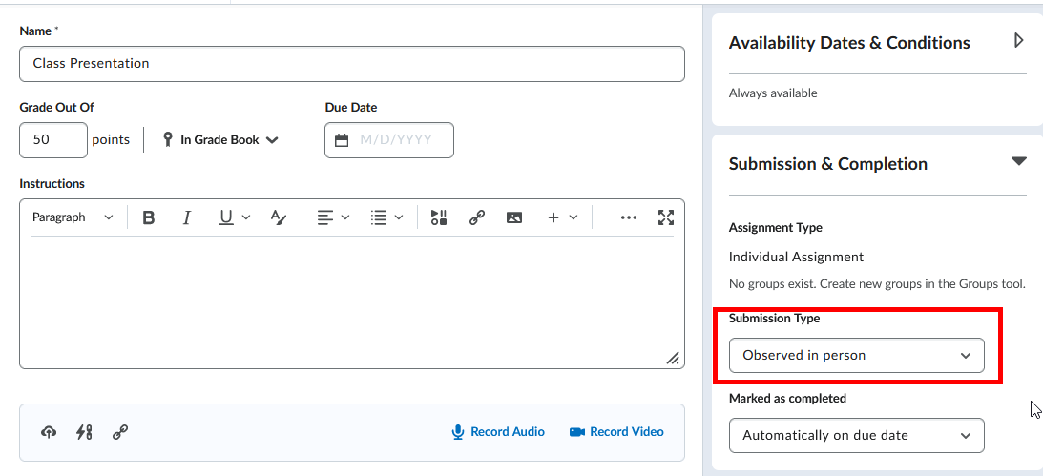

Attaching a Rubric to a Stand Alone Gradebook Column
The second option is to directly create a D2L Gradebook column and apply a rubric to that gradebook column. The D2L Gradebook is the link to where rubric data is stored and that is the reason a gradebook column must be created. Instructors can hide this gradebook column from student view if so desired.
- Select Grades, then Manage Grades.
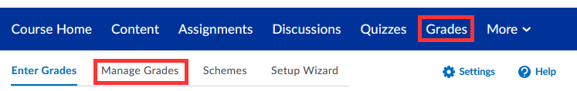
- Select New and Item (each gradebook column is considered an item).
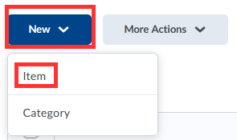
- Select a Grade Item. If no grade will be given, choose Text.
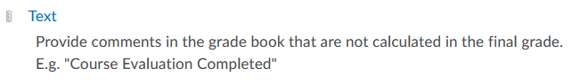
- Under the Properties tab, provide a name for the Gradebook column.
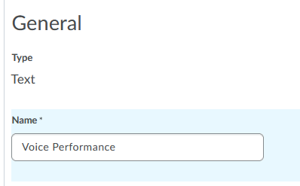
- Scroll down to the middle of this screen and select Add Rubric.
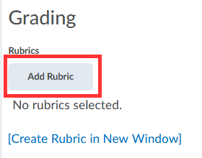
- Select one of the SSC rubrics created by the Outcomes Assessment Committee and select “Add Selected”.
- Optional: If you would like to hide this column from student view, select the Restrictions tab and select Hide from Users.
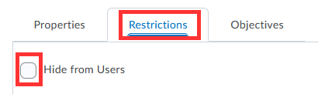

- Select Save and Close.

- Returning back to the main D2L Gradebook, a gradebook column has been created. Select the down arrow next to the gradebook column and select Enter Grades.

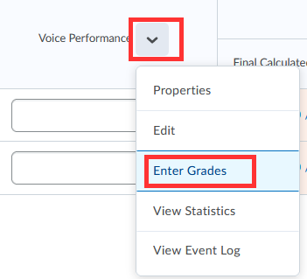

- Under the Assessment Column, select the Rubric icon for each student.
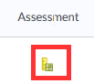
- Mouse over each criterion to apply rubric, then select Save and Close.
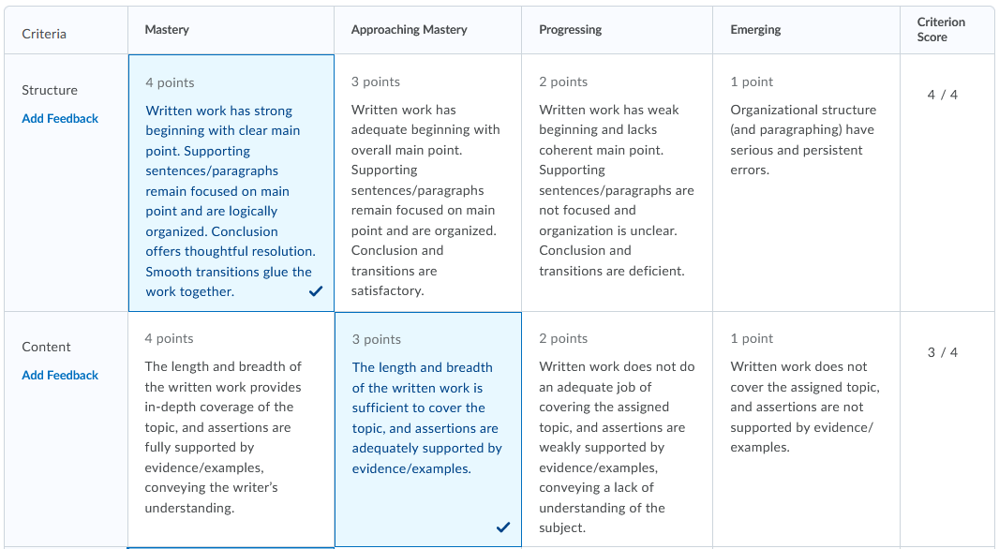
The rubric data will be sent directly to the D2L administration reports. Instructors do not need to do anything else.

Using Two Rubrics on One Assignment
Many instructors elect to use SSC general education institutional rubrics alone, as it may meet many grading needs. However, instructors do have the option to create their own unique rubric in addition to the general education institutional rubrics.
To create a second individual rubric:
- Directly below the SSC institutional rubric in the assignment from step 1 above, select Add Rubric > Create New.
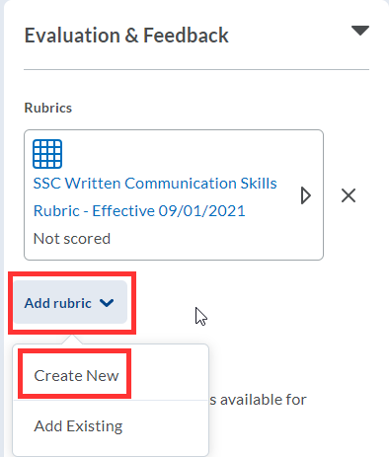

- Name the Rubric.
- In each criterion row, select the criterion text box to enter text. If you need more rows, select the + button.
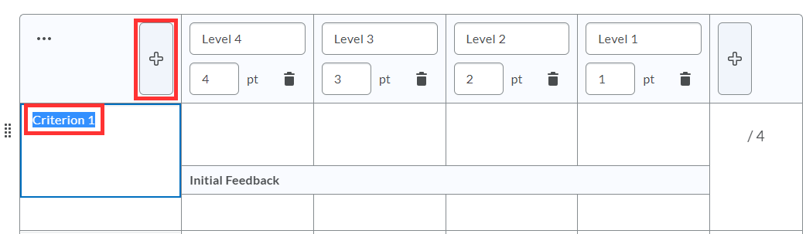
- Within each rating column, select level, point and detailed description to enter text and points.
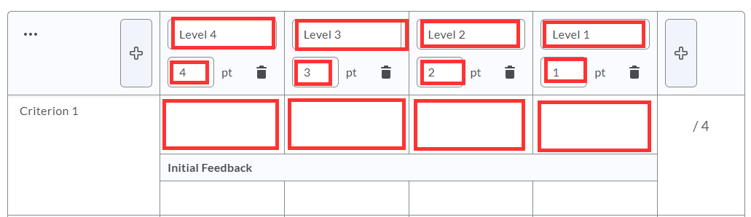
- Repeat with each criterion.
- When finished, select Attach Rubric.
- Under Default Scoring Rubric, select which rubric should send scores to the course gradebook.
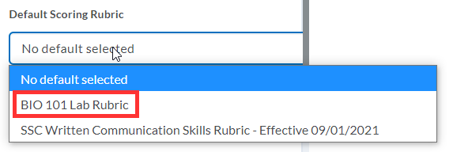
- To manage all rubrics in the course, select Course Tools > Course Admin > Rubrics.

Share a Rubric with a Colleague or Copy to Another Course

Enter D2L course that has the rubric you want to copy “from”.
- Select Course Tools (or More) and Course Admin.
- Select Import/Export/Copy.
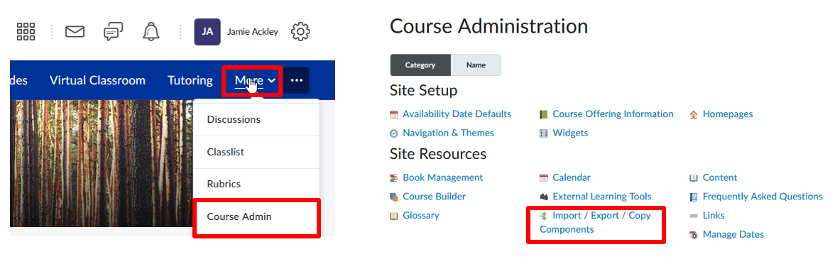
- Select Export as Brightspace Package (note – package and zip files are terms that are interchangeable and mean the same).
- Select Start.
- Under Components to Export > Select Rubrics and individual items to exports.
- Select Continue.
- Select the rubric to share or copy.
- Select Continue again.
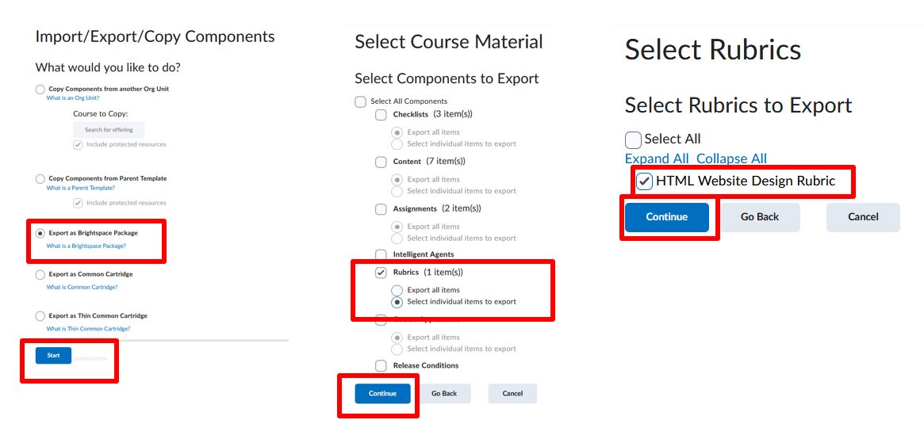
- Confirm the rubric that is being exported, then select Export.
- Alert bell will turn orange when export is ready to download.
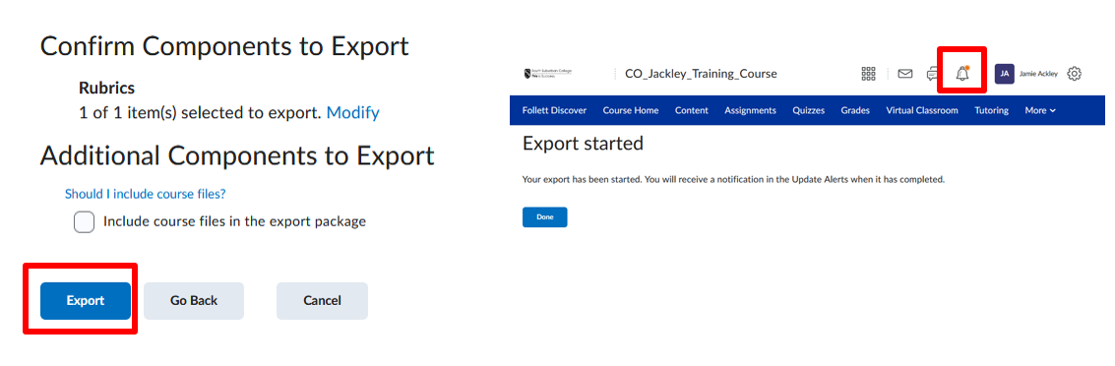
- Select alert bell and download zip file.
- Share the zip file with a colleague.
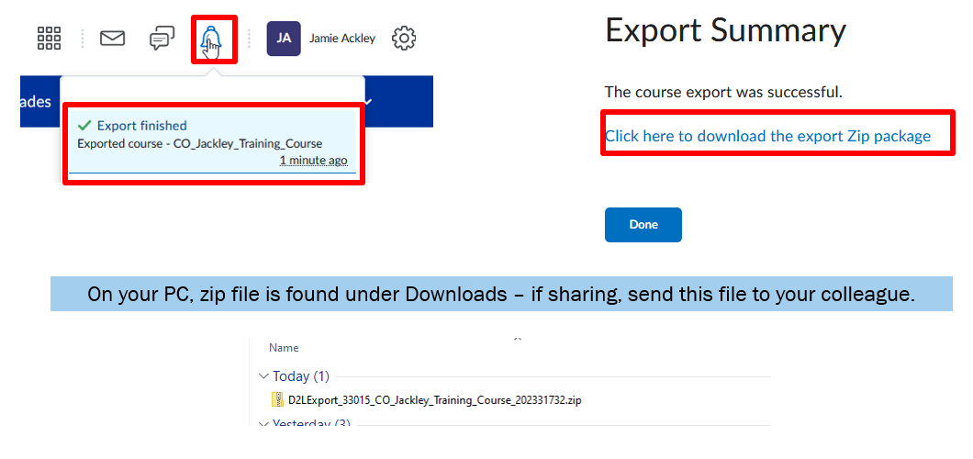
Enter D2L course that you want to copy the rubric “to”.
- Select Course Tools (or More) and Course Admin.
- Select Import/Export/Copy.
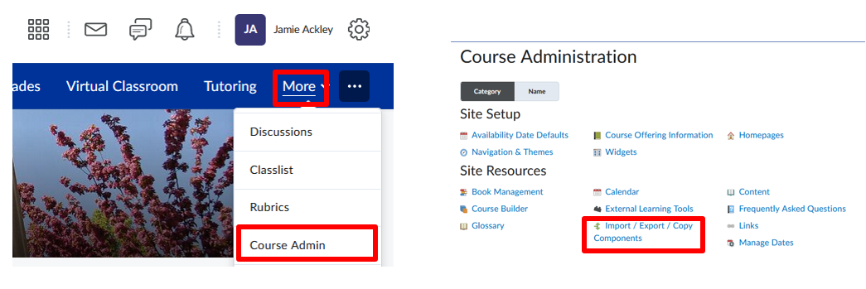
- Select Import Components from a course package (zip).
- Select Start.
- Select Upload and browse to the zip file with the rubric.
- Select Import all Components. Process may take a few moments.
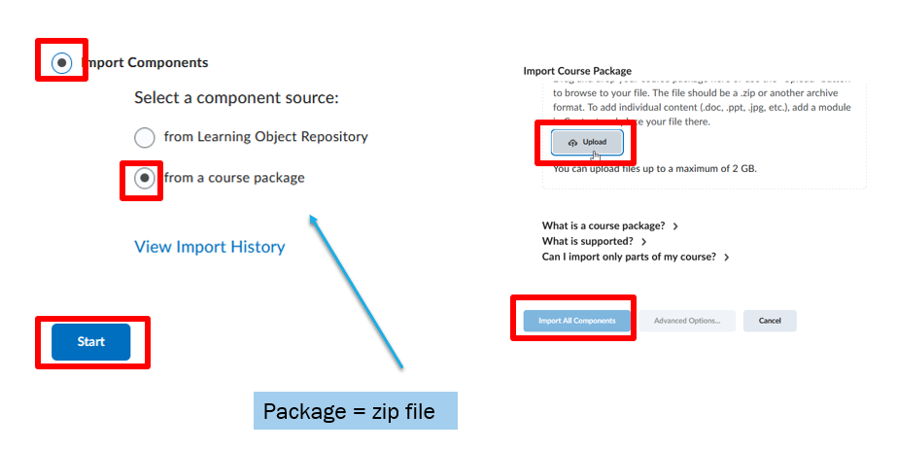
- To view the rubric import, go to Course Tools (or More) and Rubrics.
- The rubric imported should now appear in draft mode and ready to attach to an assignment or gradebook column.
