Attaching a Rubric to an Observe in Person Assignment or Stand Alone Gradebook Column

There are times when instructors would like to use a rubric in D2L which may not be considered a traditional written assignment and/or a grade may not be given. An example would be a musical performance or a voice lesson.
This can be done in two ways:

Creating an Assignment with submission type of Observe in Person
Instructors can create an assignment, as they normally do. But under Submission Type, switch to Observe in Person Assignments. Then attach a rubric. Grade the assignment like any other assignment in D2L.
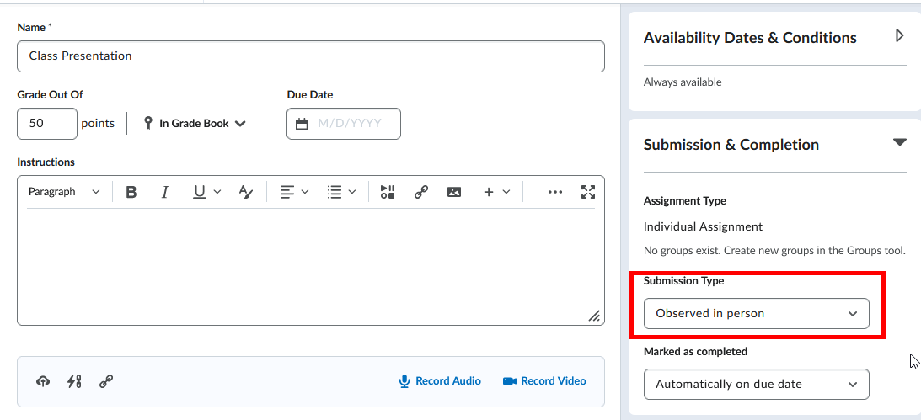

Attaching a Rubric to a Stand Alone Gradebook Column
The second option is to directly create a D2L Gradebook column and apply a rubric to that gradebook column. The D2L Gradebook is the link to where rubric data is stored and that is the reason a gradebook column must be created. Instructors can hide this gradebook column from student view if so desired.

- Select Grades, then Manage Grades.
- Select New and Item (each gradebook column is considered an item).
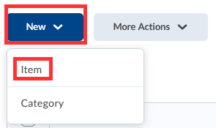
- Select a Grade Item. If no grade will be given, choose Text.
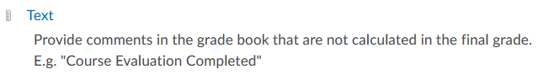
- Under the Properties tab, provide a name for the Gradebook column.
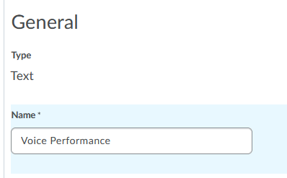
- Scroll down to the middle of this screen and select Add Rubric.
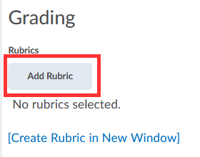
- Select one of the SSC rubrics created by the Outcomes Assessment Committee and select “Add Selected”.
- Optional: If you would like to hide this column from student view, select the Restrictions tab and select Hide from Users.
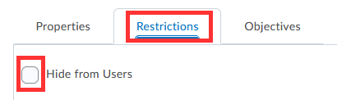

- Select Save and Close.

- Returning back to the main D2L Gradebook, a gradebook column has been created. Select the down arrow next to the gradebook column and select Enter Grades.

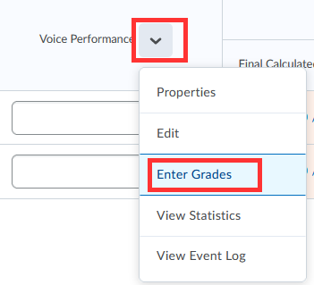

- Under the Assessment Column, select the Rubric icon for each student.
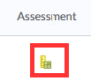
- Mouse over each criterion to apply rubric, then select Save and Close.
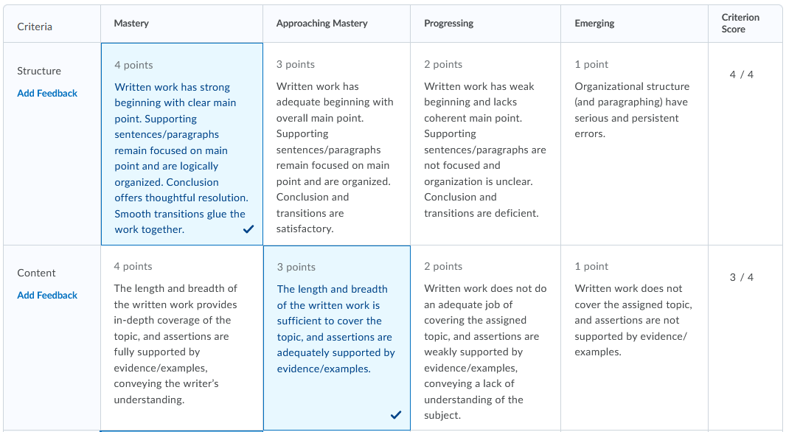
The rubric data will be sent directly to the D2L administration reports. Instructors do not need to do anything else.

