Using Two Rubrics on One Assignment
Many instructors elect to use SSC general education institutional rubrics alone, as it may meet many grading needs. However, instructors do have the option to create their own unique rubric in addition to the general education institutional rubrics.
To create a second individual rubric:
- Directly below the SSC institutional rubric in the assignment from step 1 above, select Add Rubric > Create New.
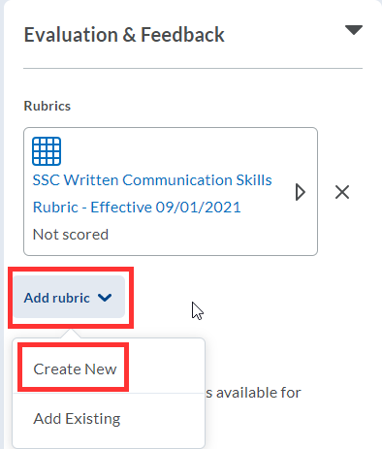

- Name the Rubric.
- In each criterion row, select the criterion text box to enter text. If you need more rows, select the + button.
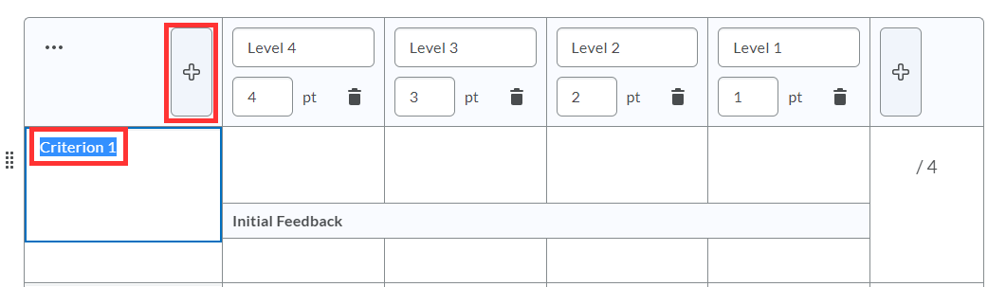
- Within each rating column, select level, point and detailed description to enter text and points.
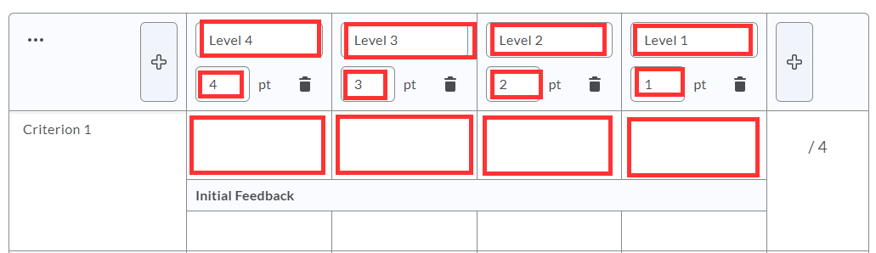
- Repeat with each criterion.
- When finished, select Attach Rubric.
- Under Default Scoring Rubric, select which rubric should send scores to the course gradebook.
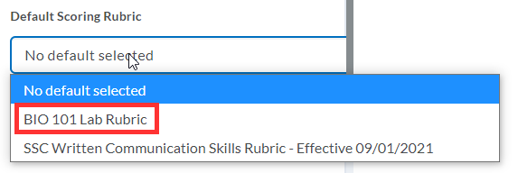
- To manage all rubrics in the course, select Course Tools > Course Admin > Rubrics.

