Grading an Assignment that Uses a Rubric
- After students have submitted their assignments > select Assignments.
- Select Drop Down next to Assignment and View Submissions.
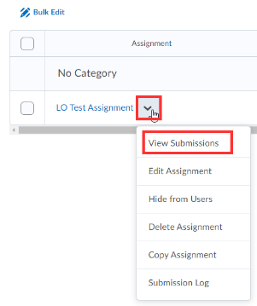
- Select a Student Submission.
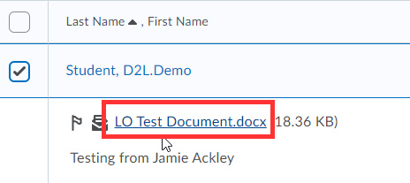
- Open Rubric.
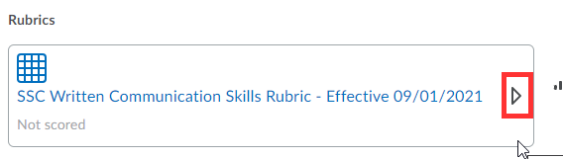
- Mouse over each criterion to apply rubric criteria to the student’s assignment.
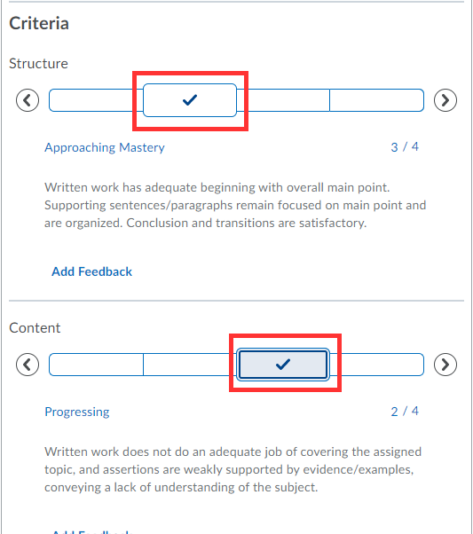
- Select Publish.

