Share a Rubric with a Colleague or Copy to Another Course

Enter D2L course that has the rubric you want to copy “from”.
- Select Course Tools (or More) and Course Admin.
- Select Import/Export/Copy.
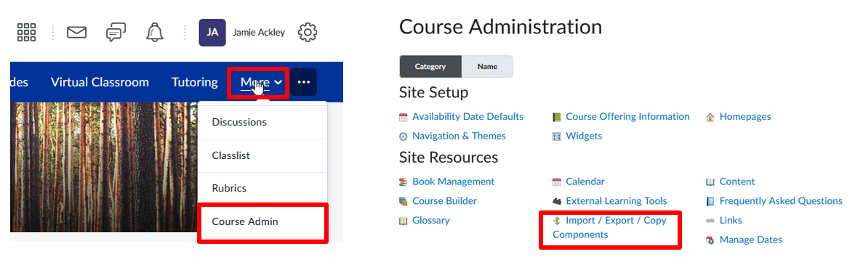
- Select Export as Brightspace Package (note – package and zip files are terms that are interchangeable and mean the same).
- Select Start.
- Under Components to Export > Select Rubrics and individual items to exports.
- Select Continue.
- Select the rubric to share or copy.
- Select Continue again.
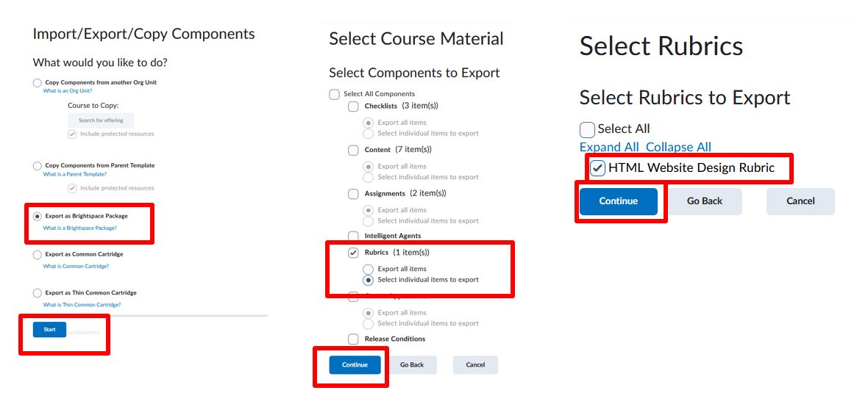
- Confirm the rubric that is being exported, then select Export.
- Alert bell will turn orange when export is ready to download.
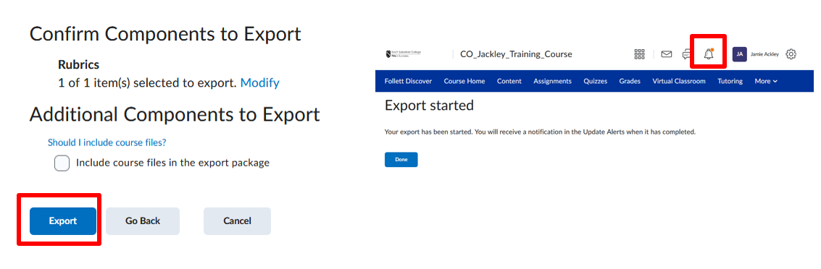
- Select alert bell and download zip file.
- Share the zip file with a colleague.
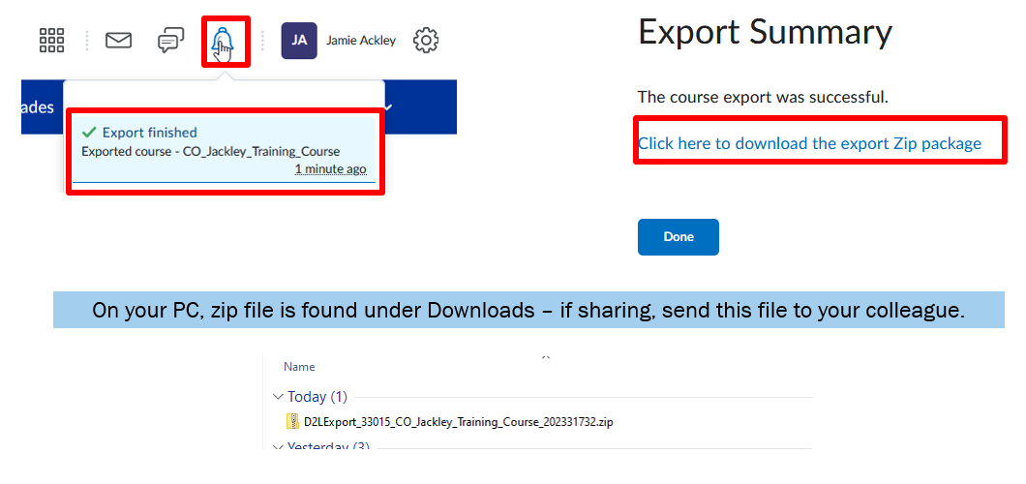
Enter D2L course that you want to copy the rubric “to”.
- Select Course Tools (or More) and Course Admin.
- Select Import/Export/Copy.
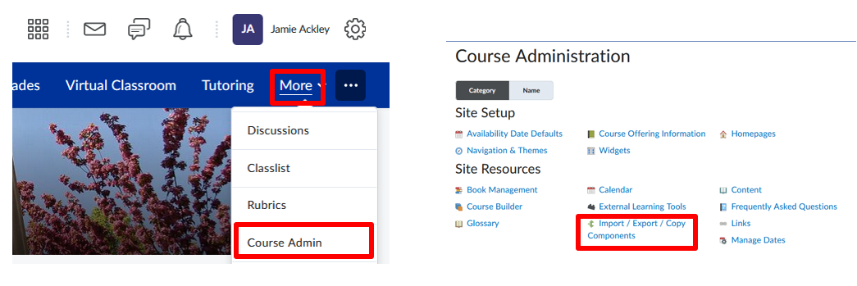
- Select Import Components from a course package (zip).
- Select Start.
- Select Upload and browse to the zip file with the rubric.
- Select Import all Components. Process may take a few moments.
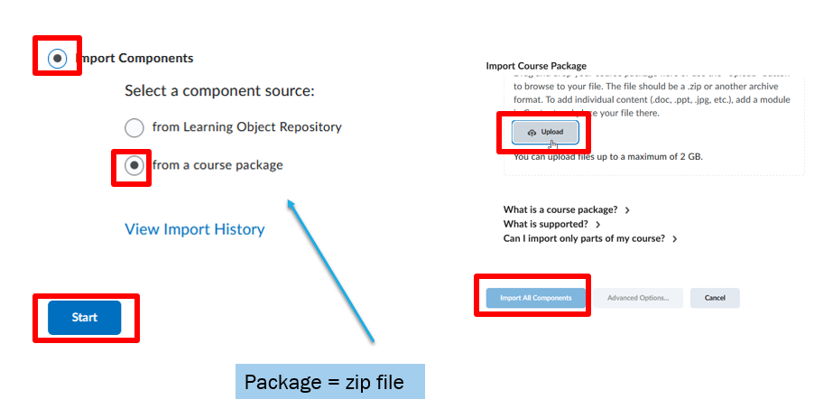
- To view the rubric import, go to Course Tools (or More) and Rubrics.
- The rubric imported should now appear in draft mode and ready to attach to an assignment or gradebook column.
