Create Your Own Rubric in D2L
- Create an D2L Assignment in the normal process.
- Under Evaluation & Feedback, select Add Rubric > Create New.
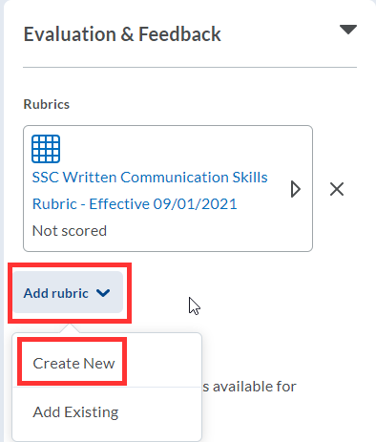
- Name the Rubric.
- In each criterion row, select the criterion text box to enter text. If you need more rows, select the + button.
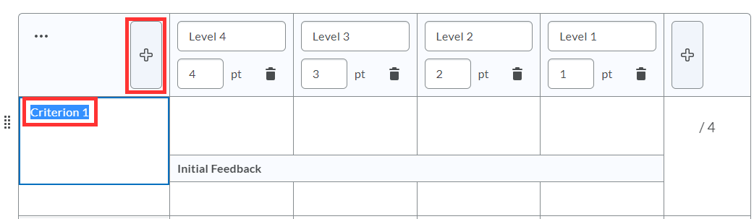
- Within each rating column, select level, point and detailed description to enter text and points.
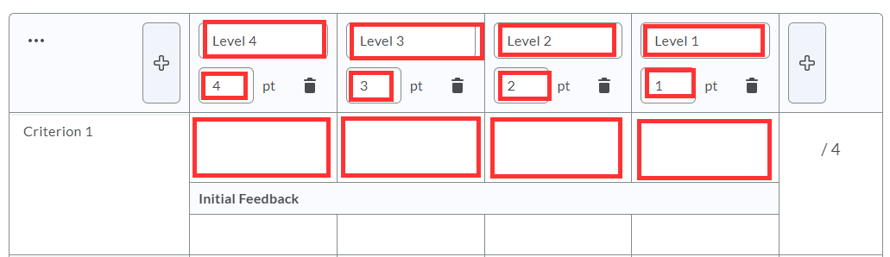
- Repeat with each criterion - when finished, select Attach Rubric.

