General Education Institutional Rubrics Reports
Since SSC is collecting data for General Education Institutional Rubrics, the college has recently rolled out and developed custom reports for instructors to view data collected for the entire institution. These custom dashboard reports can be found in the Insights Report Builder section of D2L. Here is how to access:
- After logging in to D2L and before entering a course – select:
  - Data Access > Insights Portal > Insights Report Builder.
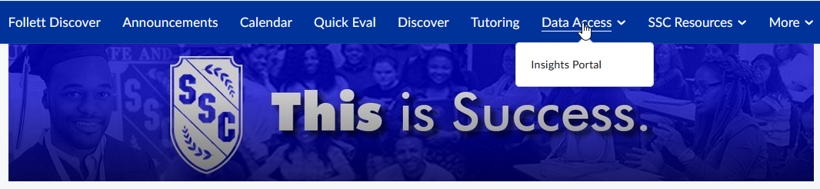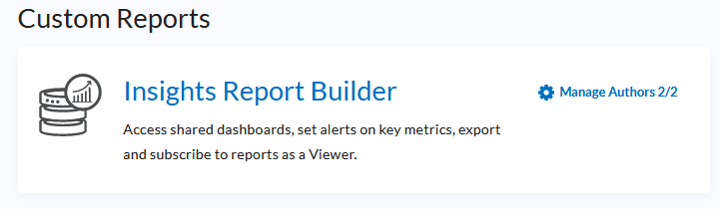

- Select three lines in upper left-hand corner to access the Dashboard.
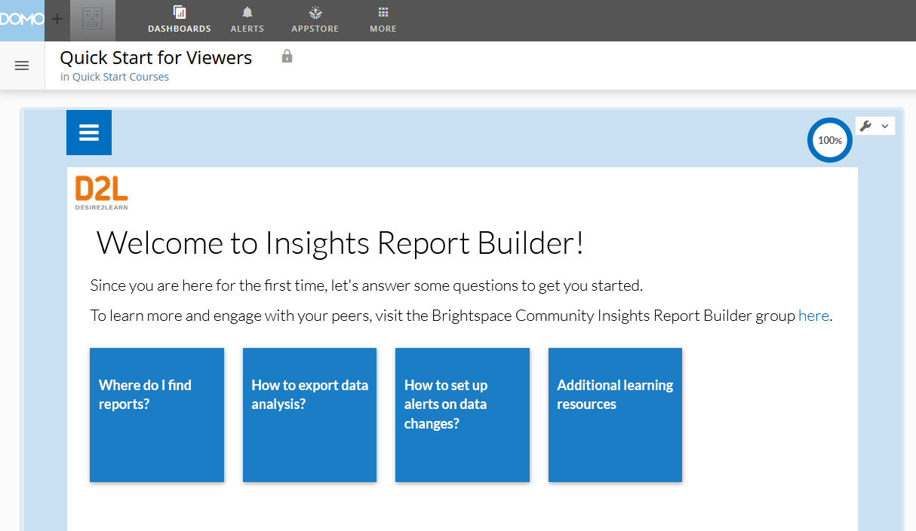
- Feel free to Pin this area, so it opens automatically next time you visit.
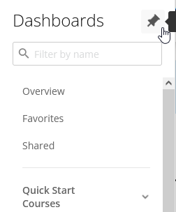
- Scroll to Institutional General Education Rubric Data Report.
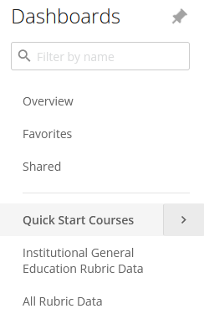
- This report is very robust with a variety of filters. Start by filtering by term.
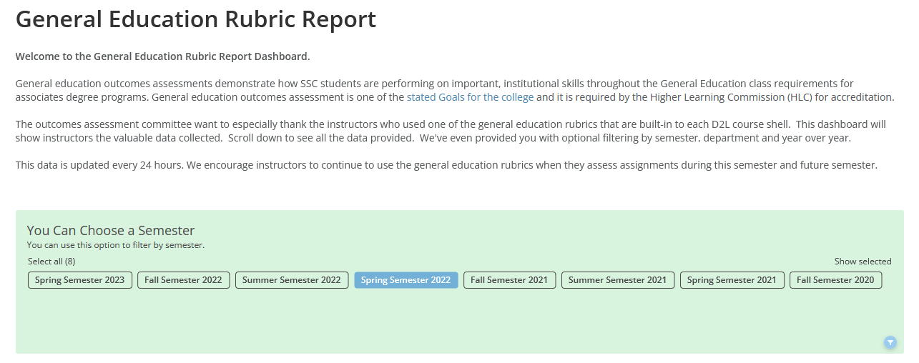
- Scroll down to see how many instructors used a General Education Institutional Rubric for that term.
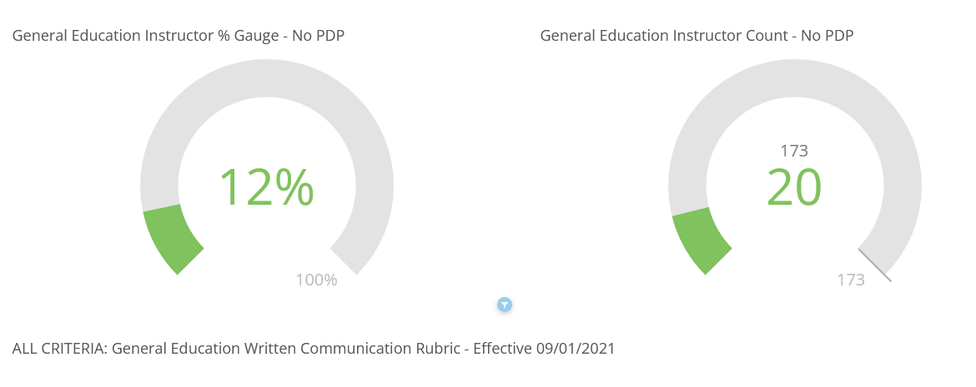
- Scroll down to see each General Education Rubric. Here is an example of the Technology Rubric and how students were accessed as a whole.
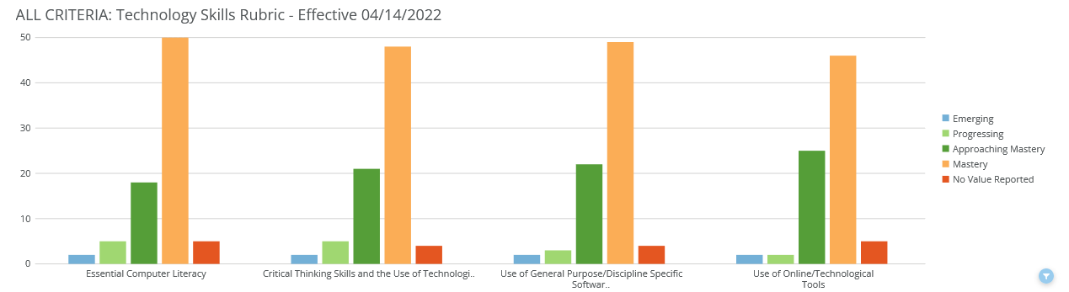
- To clear filters and start a new filter, just refresh your internet browser.

All Rubric Data
If you’d like to compare course rubric data over terms, use the All Rubric Data customized report within the Insights Report. Important – the All Rubric Data report – instructors can only see rubric data for courses they teach. They are not able to see other instructor’s rubric data.
- Select All Rubric Data.
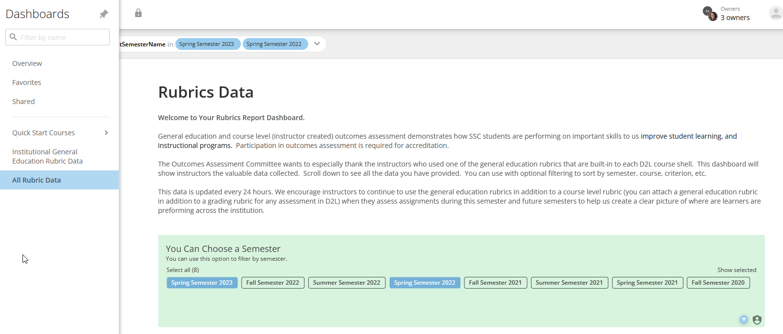
- Filter by terms (compare two terms), course, etc. and scroll down to see the custom report that was generated.
- To clear filters and start a new filter, just refresh your internet browser.

