Create an Assignment and Attach an SSC General Education Institutional Rubric
- Select Assignments in the course menu.
- Select New Assignment.
- Provide an Assignment Name.
- Complete all the fields for the assignment, such as score, due date, etc.
- Select Open Evaluation & Feedback.
- Select Add Rubric > Add Existing Rubric.
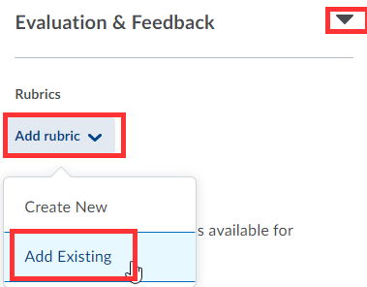
- Select an SSC General Education > and Add Selected.
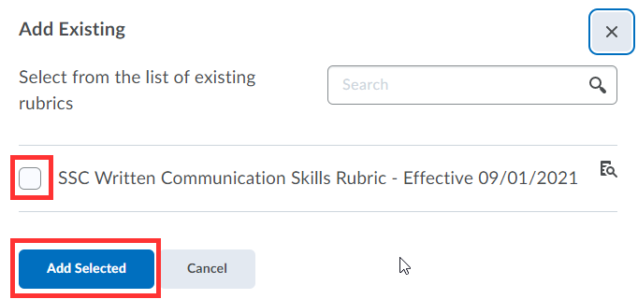

- Save Assignment.
- Rubric is now attached to this assignment.

