General Education Rubrics at SSC

South Suburban College is requesting that instructors associate an assignment in their D2L course with an SSC general education institutional rubric and then grade that assignment (2-step process is shown below). This will allow SSC to gain valuable data to improve student learning.
Optional: D2L assignments can have multiple rubrics associated with it. This means instructors can associate a second rubric they created to a D2L assignment (the one for the D2L Gradebook), in addition to the SSC general education institutional rubric. Instructor can also view course specific rubric reports to gather information about their assignments.

Contents
Step 1: Create an Assignment and Associate an SSC General Education Institutional Rubric 2
Optional: Instructor may create their own second rubric for grading 3
Step 2: Grade the Assignment 5
Optional: Instructor Rubric Reports 7
Download a Rubric Report within a Course: 9
Using D2L Rubrics in Non-Traditional Ways 10

Step 1: Create an Assignment and Associate an SSC General Education Institutional Rubric
- Select Assignments in the course menu.
- Select New Assignment.
- Provide an Assignment Name.
- Complete all the fields for the assignment, such as score, due date, etc.
- Select Open Evaluation & Feedback.
- Select Add Rubric > Add Existing Rubric.
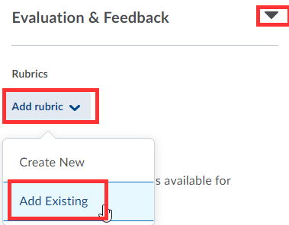
- Select SSC Written Communication Skills Rubric or SSC Technology Skills Rubric > and Add Selected.
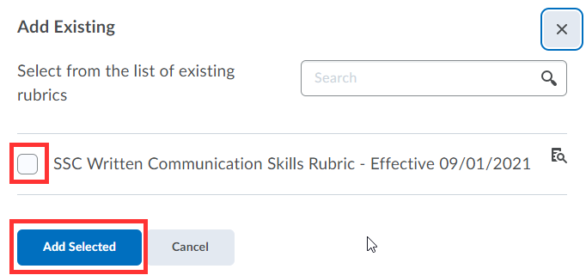

- Save Assignment.
- Rubric is now associated with this assignment.

Optional: Instructor may create their own second rubric for grading
- Many instructors elect to use SSC institutional rubrics alone, as it may meet many grading needs.
- However, instructors do have the option to create their own unique rubric in addition to the institutional rubrics.
- If using SSC institutional rubrics only, skip directly to Step 2 below.

To create a second individual rubric:
- Directly below the SSC institutional rubric in the assignment from step 1 above, select Add Rubric > Create New.
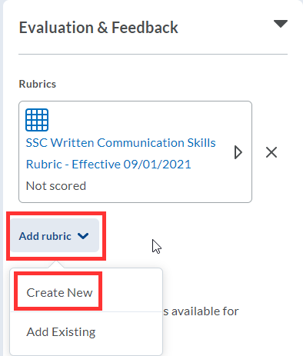

- Name the Rubric.
- In each criterion row, select the criterion text box to enter text. If you need more rows, select the + button.
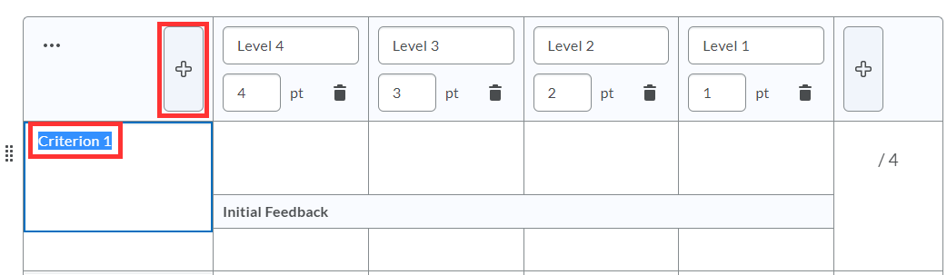
- Within each rating column, select level, point and detailed description to enter text and points.
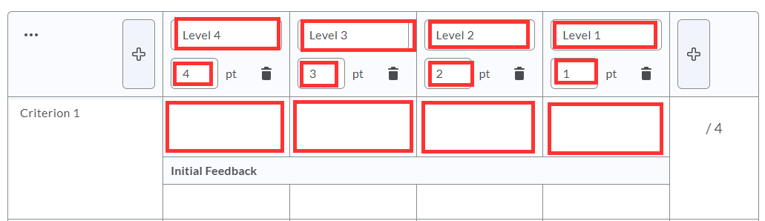
- Repeat with each criterion.
- When finished, select Attach Rubric.
- Under Default Scoring Rubric, select which rubric should send scores to the course gradebook.
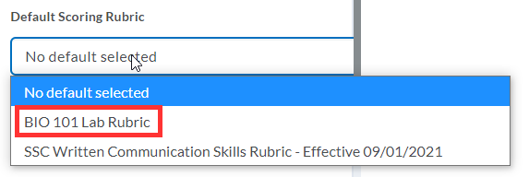
- To manage all rubrics in the course, select Course Tools > Course Admin > Rubrics.
- To learn more about creating course rubrics, see Creating a Rubric in D2L: https://www.youtube.com/watch?v=G5h2qiaN1o8

Step 2: Grade the Assignment
- After students have submitted their assignments > select Assignments.
- Select Drop Down next to Assignment and View Submissions.
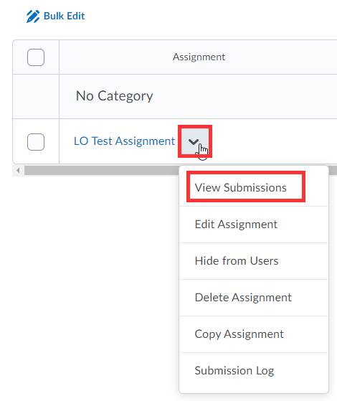

- Select a Student Submission.
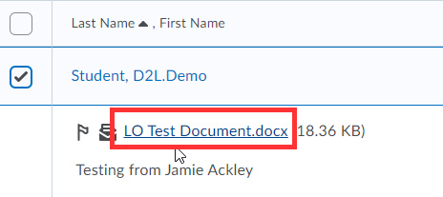

- Open Rubric
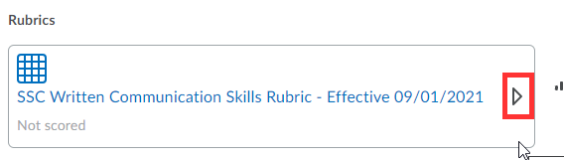

- Mouse over each criterion to apply rubric criteria to the student’s assignment.
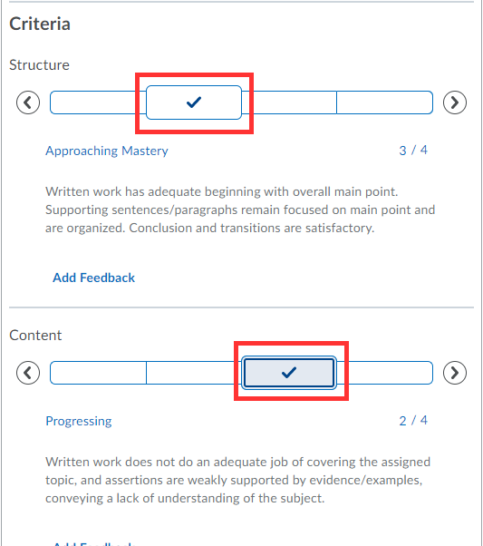

- Select Publish.

Optional: Instructor Rubric Reports
After grading an assignment, general education institutional rubrics data is sent directly to the D2L administration reports. Instructors do not need to do anything else.
However, if instructors would like to view statistic reports on rubrics in their course, there are two ways to view this report.
- Assignment specific reports:
- Once you have completed your grading on an assignment, go back to the assignment and select View Submissions.

- Select Published.
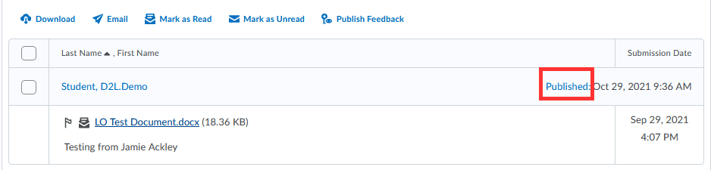

- Select the Chart Icon next to the rubric.
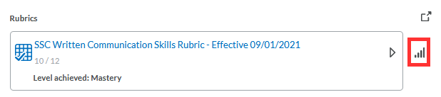
- Select Criteria Statistics or Individual Statistics
- Criteria Statistics show the percentage of students that were graded on each criteria level. This allows an instructor to determine if they need to review content with students or whether students are on the right track.
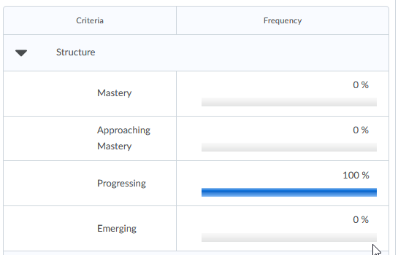
- Individual Statistics will show the overall scoring for each individual student.

- Rubric specific reports:
If you used the same rubric on a variety of writing assignments, for example, and you don’t want to go to each individual assignment to review the rubrics statistics report, go to the main rubrics tool.
- Go to Course Tools > Course Admin> Rubrics.
- All rubrics associated with the course will appear.
- Select View Statistics next to the rubric.
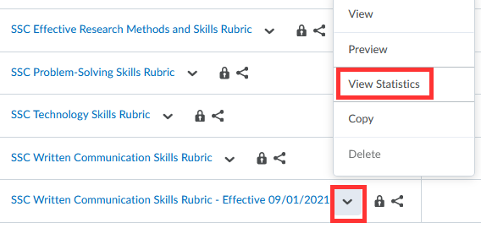
- Click on Competency Activities.
- This will show all the assignments that used the same rubric.
- Click on the Chart Icon next to each assignment to drill down on the data for that particular assignment.
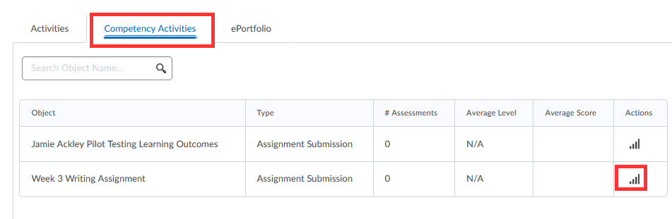

Download a Rubric Report within a Course:
- D2L does not include a download button when reviewing rubric results (D2L promises this is coming soon).
- A suggested workaround:
  - Open a new blank word document.
  - When looking at the D2L Rubric Reports, perform a screen capture (copy and paste doesn’t always work well in formatting – so screen capture works best).
  - How to perform a screen capture?
    - PC: select windows logo button, shift and the letter “S”.
    - Mac: shift, command button and number “3”.
  - Go back to the blank word document and select paste.
  - Save your word document when complete.

Using D2L Rubrics in Non-Traditional Ways
There are times when instructors would like to use a rubric in D2L which may not be considered a traditional written assignment and/or a grade may not be given. An example would be a musical performance or a voice lesson.
Instead of creating an assignment, where a student uploads content to be graded, instructors can directly create a D2L Gradebook column and apply a rubric to that gradebook column. The D2L Gradebook is the link to where rubric data is stored and that is the reason a gradebook column must be created. Instructors can hide this gradebook column from student view if so desired.
- Select Grades, then Manage Grades.
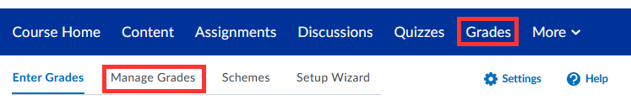
- Select New and Item (each gradebook column is considered an item).
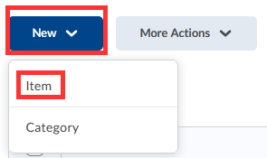
- Select a Grade Item. If no grade will be given, choose Text.
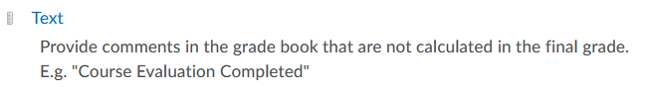
- Under the Properties tab, provide a name for the Gradebook column.
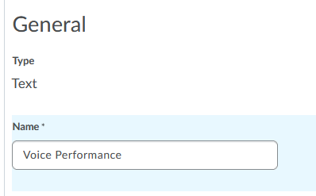
- Scroll down to the middle of this screen and select Add Rubric.
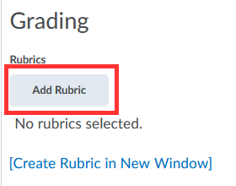
- Select one of the SSC rubrics created by the Outcomes Assessment Committee and select “Add Selected”.
- Optional: If you would like to hide this column from student view, select the Restrictions tab and select Hide from Users.
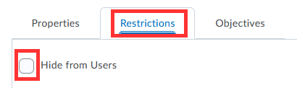

- Select Save and Close.

- Returning back to the main D2L Gradebook, a gradebook column has been created. Select the down arrow next to the gradebook column and select Enter Grades.

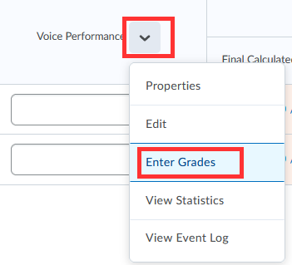

- Under the Assessment Column, select the Rubric icon for each student.
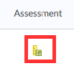
- Mouse over each criterion to apply rubric, then select Save and Close.
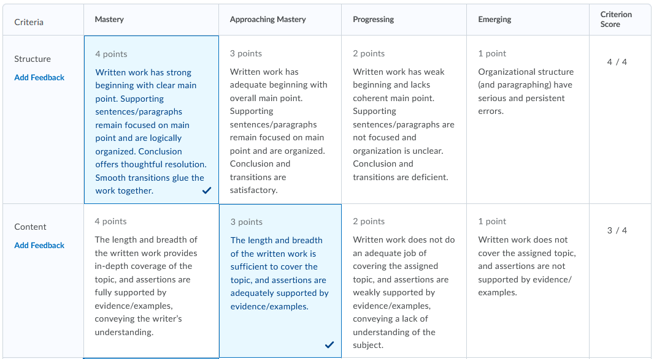

The rubric data will be sent directly to the D2L administration reports. Instructors do not need to do anything else.

